**Morse code**

Dot and dashes

Length of dash is three times that of dot and pause is equal to the duration of dot

Letters in same word are separated by the duration of 1 dash or 3 dots

Words are separated by 2 dashes or 6 dots

Code, is a system of transferring information between man and machine

SOS, international distress signal is 3 dots, 3 dashes and 3 dots

Speech is about 100 words per minute

See the arrangement below

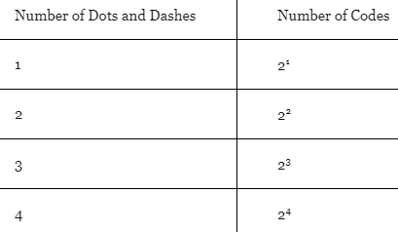

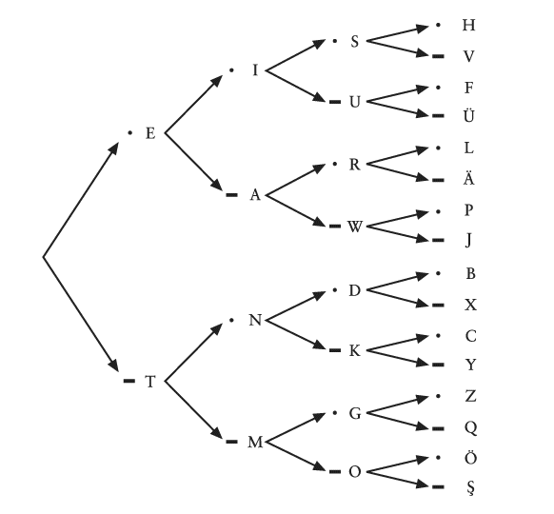

Easy way to back track from the dots and dashes to the letters

**Braille**

Charles barbier, captain of French army devised a writing method of raised dots and dashes to be used in night. Louie Braille advanced this system to be simpler and devised his system which is still used.

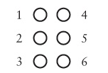

Bigger ones are raised and smaller ones are not



Each dot can either have 2 options, so the total possibilities of representation is 2^6 = 64

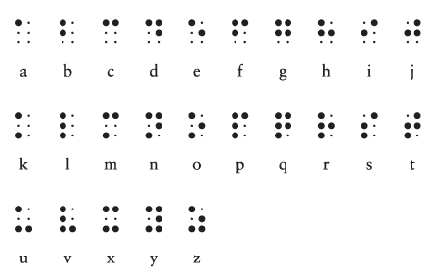

I figured, easy way to remember would be, if the dots are in the first 4 then it is within a-j and then if the bottom 2 dots are active then it is u-z and then rest is k-t

**Electricity**

Dislodge electron from the atom in a conductor and bring that under the influence of an electric field such that it moves in the right direction.

Even the electrons out

One atom loses another gain

Chemical reaction in a battery is engineered such that excess electrons are generated at minus and a deficit is created at positive terminal

Negative is anode and positive is cathode

Best conductors are copper, silver and gold

Longer a wire, higher the resistance

Thicker wire means less resistance. Using a pipe analogy, bigger the cross section the water can move smoothly compared to the smaller one.

Voltage is the potential to do work

To get 1amp of current you need 6.240 x 10^18 electrons flowing past a point per second

Ohms Law V = IR

Dry air molecules have very high resistance hence the circuit is open when you hold out a battery in the air

Tungsten inside a bulb glows in vacuum where it does not heat up

Batteries are connected in series

Power P = V x I

100 - 200 milli Amps is lethal

Common, is the part of the that is shared between two circuits

The common can be replaced with earth

Bigger the better, so earth is a very good conductor

To establish connection with earth, you need a large surface area, preferably eight feet pole with ½ inch diameter

Since the setup is same at your house and your friend’s house, the earth can be used as a connector

The resistance of earth is too much for simple applications, hence you need high voltage

+ And – will complete circuit

-And ground will complete

But Positive and ground wont

It is either called positive or neutral, it is better not to call positive because AC current keeps changing direction

Either call hot or neutral

95% of the internet traffic is routed on the transatlantic cables submerged deep in the oceans

Communicating through the satellites is very expensive and has less bandwidth

The transatlantic cables were first established way back in 1860 for telegraphic communication using Morse code

Now they use heavy duty cable for the same job, submerged at about 6000 meters undersea

It seems all the financial data is sent using separate cables that transfer data faster

**Back to Morse**

Take an iron bar, run some wires to it and then supply current and that bar becomes a electro magnet

What hath god wrath

What has god done, was the first message sent on telegraph

Earliest telegraph created by Morse would use electro-magnetism to automate the sending of message

Dot and dash

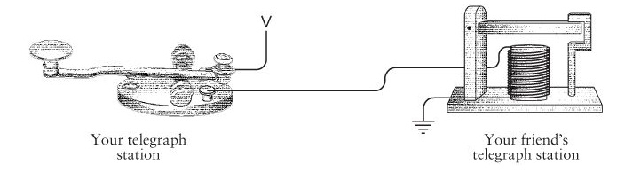

As you pressed the switch on telegraph that will send the electricity down the receiver end and do some mechanical work using the electro magnet

Connect the sounder systems at the receiver to key and you got a relay system that is basically repeating the message which is required for long distance communication of the time

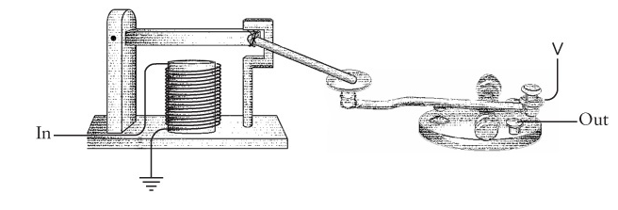

**Numbers**

The number system that we use today is the Indo-Arabic system

Zero is the major contribution of Indian system, zero

Octal system 0, 1,2,3,4,5,6,7

There is no 8 as in there is no special symbol for ten in decimal

So next would be 10, 11, 12, 13, 14, 15, 16, 17, and 20

Numbers of fingers cartoons have 8 to the base ten or 10 to the base eight

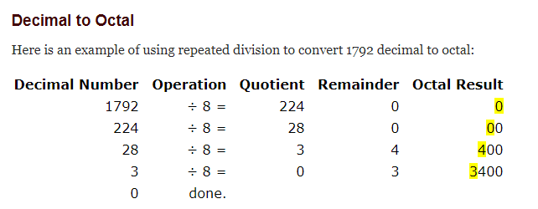

Do the octal addition and multiplication the same as addition

Whenever the numbers becomes big replace with octal equivalent

Binary number system bridges the gap between the arithmetic and electricity

Binary digit is bit

**Bit**

Log 128 to the base 2 gives 7

What this means, you need 7 bits for 128 possibilities

Depending upon the sensitivity of the camera reel, which is established either through 1 or 0 through silver and black, the camera will then adjust the light exposure to match the camera reel

**UPC Universal Product Code**

30 bars of different width and different gaps

OCR optical character recognition to detect numbers

As the scanner reads it assigns 1 bit for the black bar and 0 for the space in between

Bigger the bar more the bits



In total there are 95 bits

The first 3 and last 3 bits are guard patterns

Then there series of 6 seven digit numbers followed by Centre guard

Centre guard is always the same and if it is not where it is supposed to be then the code is wrong

This is followed by another series of seven digit numbers

If the scanner cannot read the code then the person can register manually by looking into the below numbers

UPC generally does not include price info, only the product info

The last number is modulo check, basically you assign each digit a system and calculate the modulo and then compare that with the one given, if they both do not match then the UPC is not valid

Odd bits is odd parity and even bits is even parity

Bits can represent many things; all you need to do is count number of each possibility

**Logic and Switches**

Aristotle syllogism to find the truth

All men are mortal, Socrates is a man; therefore Socrates is mortal

George Boole, son of shoe maker and maid, studied mathematics

Conventional algebra has rules, addition and multiplication are commutative

A+B = B+A

AxB = BxA

Associative

A+ (B+C) = (A+B) +C

Distributive

A x (B+C) = A x B + A x C

Boolean algebra is made up of classes/set

Set mainly has two operation, union and intersection

The commutative, associative and distributive rules hold good in Boolean algebra

Boolean algebra different to conventional algebra F X F = F

F + F = F again a contradiction to conventional algebra

AND intersection X

OR union +

NOT except –

Charles Babbage knew George Boole

102

**Gates**

Realizing the Boolean expressions through electric circuits

Claude Shannon, father of realising switching circuits using Boolean algebra for various applications

Father of information theory

Using electrical switches to implement logic is the basis of digital circuit design

His book symbolic analyses of relay and switching circuits and mathematical theory of communication is the basis of digital circuits and information theory

Shannon met Edison and Alan Turing during his time

Shannon is a genius; his mouse device was one of the first experiments in AI

Shannon showed how to use Boolean algebra to design electric circuits to analyse and synthesis network

Relays are like switches except that they can be closed or opened by another relay compared to switches and combination of relays are called logic gates

These relays can be used to perform complex operations

How relay is acting like a switch, relay needs a small current to activate the lever

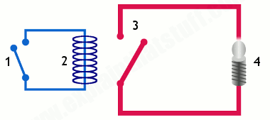

Once that is done, it will activate higher current in different circuit power the light

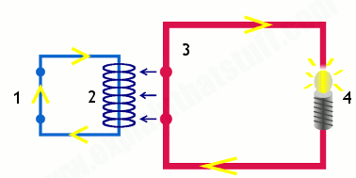

|  |  |  |  |
| --- | --- | --- | --- |
| **AND Gate** |  |  |  |
| **OR Gate** |  |  |  |
| **Inverter** |  |  |  |
| **NOR Gate**  **Opposite OR** |  |  | The inputs to the gate is reversed using **inverter** for both inputs hence its on when both inputs are off |
| **NAND Gate** |  |  | Here there are no inverters, but due to the configuration of relays the output is reversed |
| **Buffer** |  |  | Input is same as output. This is used to delay signal or |

Logic gates have 2 or more inputs

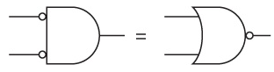

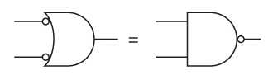

Above two are the implications of De Morgan’s Law

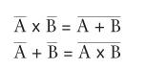

131